REFLECTION WORKSHEET

Compassionate Activism Model

100% Committed to a Vision

100% Acknowledging of Current Reality

In Community, In Every Moment

The Five Practices of Compassionate Activism

  - Humility and Curiosity
  - Distinguishing Realities and Acknowledging External Reality
  - Gentle Mindfulness and Compassionate Self-Accountability
  - Compassionate Truth-Telling and Consciousness-Raising Inquiry
  - Shared Envisioning and Non-Cooperation

Select a Situation

In order to integrate this model into your daily life, please select a common situation you face to use throughout the session.

  - What is a type of situation that is moderately emotionally charged for you?

  - Why is it emotionally charged for you?

  - What is your typical reaction to it?

Practice #1 - Humility and Curiosity

Our initial reaction to a situation is often just the tip of the iceberg. When we believe our initial reaction and the assumptions behind them are 100% true and grounded in reality, then we aren’t able to create something different. So treating our initial reaction and assumptions as just a starting point and as speculations is key to creating a different response to the situation.

Reflecting on Your Typical Reaction
  - What gets in the way of you acknowledging that you might not know everything about this situation already?

  - What gets in the way of you being curious about the other person’s internal reality and asking questions to learn more?

  - What gets in the way of you being curious about your own internal reality and digging deeper to get in touch with it?

Practice #2: Distinguishing Realities and Acknowledging External Reality

There are three realities operating at the same time in all situations. When we confuse them as one reality, we run into issues because that is not how they’re experienced by us. The three realities are:
  - Your internal reality
  - The other person’s internal reality
  - External reality

External reality consists of:
  - Words
  - Actions
  - Energy

Our ability to accurately receive and assess external reality is affected by how emotionally charged we are around the situation. So the first step is to start distinguishing external reality from our internal reality and acknolwedge that what happened in external reality did indeed happened.

Reflecting on Your Typical Reaction To the Situation
  - Share briefly what you normally think and talk about regarding the situation.

  - With the help of your partner, identify what parts are make believe.

  - Describe what was said and done in that specific situation between you and the other person(s). Focus on the words and actions only.

  - Keep paring down your description until you and your partner feel like it’s just composed of the words and actions.

Reflecting on Your Reflections
  - What gets in the way of you acknowledging the situation as it is and as it is not?

  - What do you gain from resisting the reality and focusing on make believe?

  - What’s the impact on you when you don’t acknowledge the situation as it is?

Reflecting on Acknowledging as Acceptance
  - Share “I accept that they said X.”

  - What and how is it different for you when you just focus on the words and actions and accept that they happened as such – and not as you wished had happened?

Practice #3: Gentle Mindfulness and Compassionate Self-Accountability

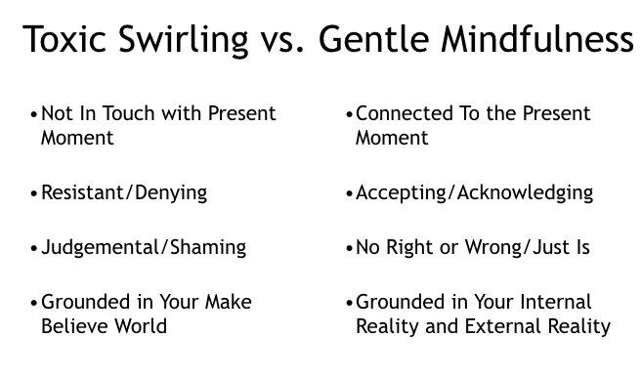
Normally, we’re caught in a mental swirl - which is usually toxic. This prevents us from getting in touch with our internal reality because our mental energy and time is being poured into resisting the existence of reality aka make-believe.

To shift from the toxic swirl to our internal reality, we bring mindfulness to our internal reality. To break out of the grips of the toxic swirl, use the first Practice of Humility and Curiosity and second Practice of Distinguishing Realities and Acknowledging External Reality to let go of the toxic swirl.

Then bring gentle attention to your internal reality and acknolwedge it without trying to change it, judge it, minimize it, etc.

Reflecting on Practicing Mindfulness
  - Share briefly what your typical toxic swirl is around the situation.
  - Share what it was like when you brought mindfulness to your reaction.
  - How was mindfulness different or similar than the toxic swirl?

Practice #4: Compassionate Truth-Telling and Consciousness-Raising Inquiry

Ways We Often Relate

We relate to the other person and their experiences like how we often relate to our own feelings - through our toxic swirl.

- We make them wrong as a person:
      - Judge them
      - Shame them
      - Police them
      - Dismiss them
- We resist their experience of the situation (aka their internal reality):
      - Deny and minimize what they’re feeling
      - Focus on how they ‘should’ be feeling (aka make believe world)
      - Try to force them to agree with us (aka push our internal reality on to them)

Just like we let go of our toxic swirl and got reconnected to and unpacked our own internal reality through mindfulness, we can let go of our toxic swirl around their other person and invite them to share and unpack their internal reality with us.

If we approach them AFTER we’ve let go of our toxic swirl and have taken care of our own pain and are reconnected with our internal reality, then there’s greater chance of them responding in kind.

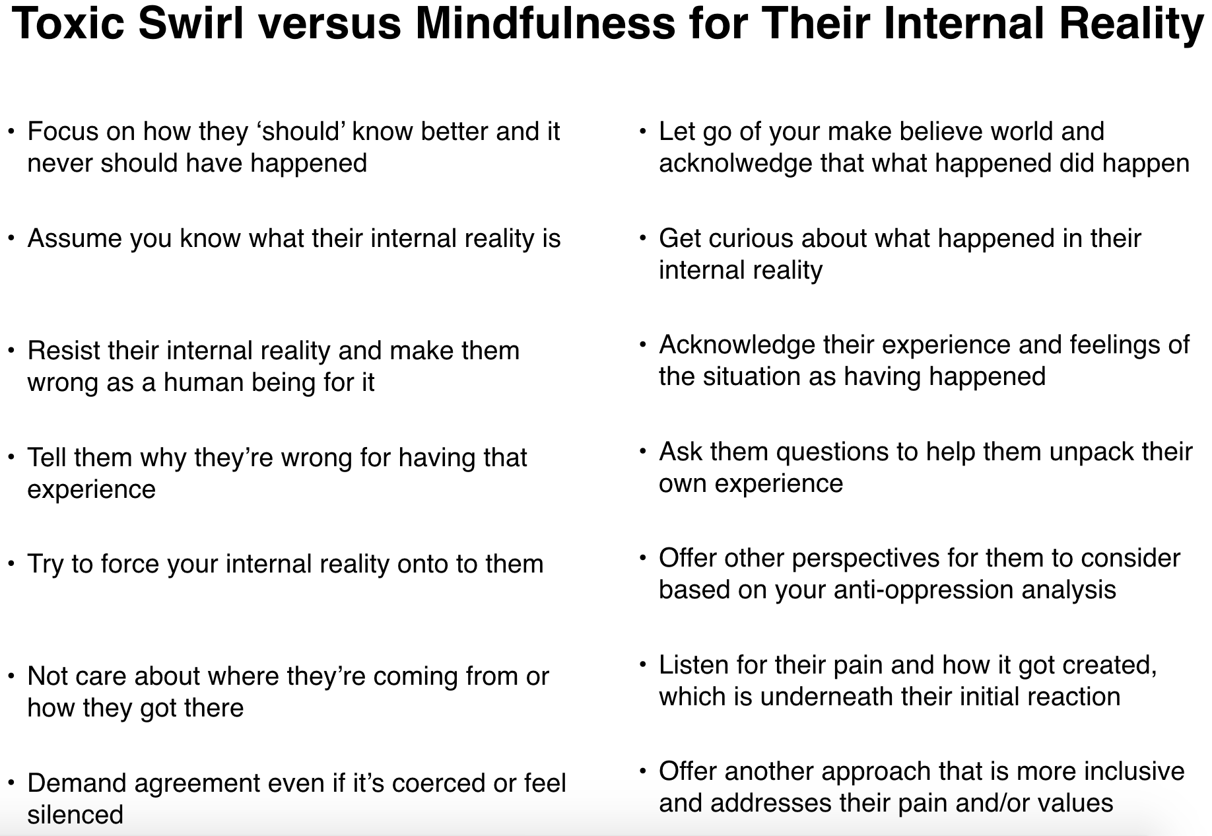
However if we approach BEFORE we’ve taken care of ourselves, then we will approach them with toxic swirl - and that almost never goes well.

