REFLECTION WORKSHEET

Compassionate Activism Model

100% Committed to a Vision

100% Acknowledging of Current Reality

In Community, In Every Moment

The Five Practices of Compassionate Activism

  - Humility and Curiosity
  - Distinguishing Realities and Acknowledging External Reality
  - Gentle Mindfulness and Compassionate Self-Accountability
  - Compassionate Truth-Telling and Consciousness-Raising Inquiry
  - Shared Envisioning and Non-Cooperation

Quick Summary of the Five Practices: Breath, Listen, Invite

Select a Situation

In order to integrate this model into your daily life, please select a common situation you face to use throughout the session.

  - What is a type of situation that is moderately emotionally charged for you?

  - Why is it emotionally charged for you?

  - What is your typical reaction to it?

Practice #1:
Humility and Curiosity

Our initial reaction to a situation is often just the tip of the iceberg. When we believe our initial reaction and the assumptions behind them are 100% true and grounded in reality, then we aren’t able to create something different. So treating our initial reaction and assumptions as just a starting point and as speculations is key to creating a different response to the situation.

Reflecting on Your Typical Reaction
  - What gets in the way of you acknowledging that you might not know everything about this situation already?

  - What gets in the way of you being curious about the other person’s internal reality and asking questions to learn more?

  - What gets in the way of you being curious about your own internal reality and digging deeper to get in touch with it?

Practice #2:
Distinguishing Realities and Acknowledging External Reality

There are three realities operating at the same time in all situations. When we confuse them as one reality, we run into issues because that is not how they’re experienced by us. The three realities are:
  - Your internal reality
  - The other person’s internal reality
  - External reality

External reality consists of:
  - Words
  - Actions
  - Energy

Our ability to accurately receive and assess external reality is affected by how emotionally charged we are around the situation. So the first step is to start distinguishing external reality from our internal reality and acknolwedge that what happened in external reality did indeed happened.

Reflecting on Your Typical Reaction To the Situation
  - Share briefly what you normally think and talk about regarding the situation.

  - With the help of your partner, identify what parts are make believe.

  - Describe what was said and done in that specific situation between you and the other person(s). Focus on the words and actions only.

  - Keep paring down your description until you and your partner feel like it’s just composed of the words and actions.

Reflecting on Your Reflections
  - What gets in the way of you acknowledging the situation as it is and as it is not?

  - What do you gain from resisting the reality and focusing on make believe?

  - What’s the impact on you when you don’t acknowledge the situation as it is?

Reflecting on Acknowledging as Acceptance
  - Share “I accept that they said X.”

  - What and how is it different for you when you just focus on the words and actions and accept that they happened as such – and not as you wished had happened?

Practice #3:
Gentle Mindfulness and Compassionate Self-Accountability

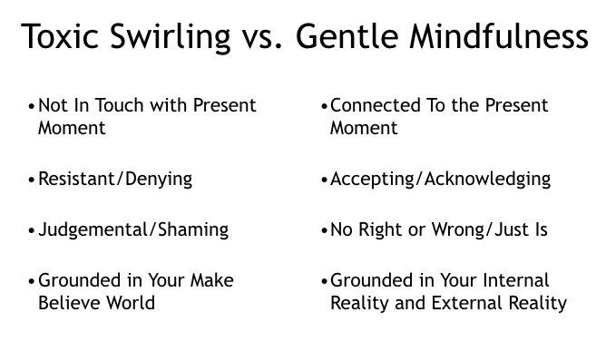
Normally, we’re caught in a mental swirl - which is usually toxic. This prevents us from getting in touch with our internal reality because our mental energy and time is being poured into resisting the existence of reality aka make-believe.

To shift from the toxic swirl to our internal reality, we bring mindfulness to our internal reality. To break out of the grips of the toxic swirl, use the first Practice of Humility and Curiosity and second Practice of Distinguishing Realities and Acknowledging External Reality to let go of the toxic swirl.

Then bring gentle attention to your internal reality and acknolwedge it without trying to change it, judge it, minimize it, etc.

Reflecting on Practicing Mindfulness
  - Share briefly what your typical toxic swirl is around the situation.
  - Share what it was like when you brought mindfulness to your reaction.
  - How was mindfulness different or similar than the toxic swirl?

Practice #4:
Compassionate Truth-Telling and Consciousness-Raising Inquiry

Ways We Often Relate

We relate to the other person and their experiences like how we often relate to our own feelings - through our toxic swirl.

- We make them wrong as a person:
      - Judge them
      - Shame them
      - Police them
      - Dismiss them
- We resist their experience of the situation (aka their internal reality):
      - Deny and minimize what they’re feeling
      - Focus on how they ‘should’ be feeling (aka make believe world)
      - Try to force them to agree with us (aka push our internal reality on to them)

Just like we let go of our toxic swirl and got reconnected to and unpacked our own internal reality through mindfulness, we can let go of our toxic swirl around their other person and invite them to share and unpack their internal reality with us.

If we approach them AFTER we’ve let go of our toxic swirl and have taken care of our own pain and are reconnected with our internal reality, then there’s greater chance of them responding in kind.

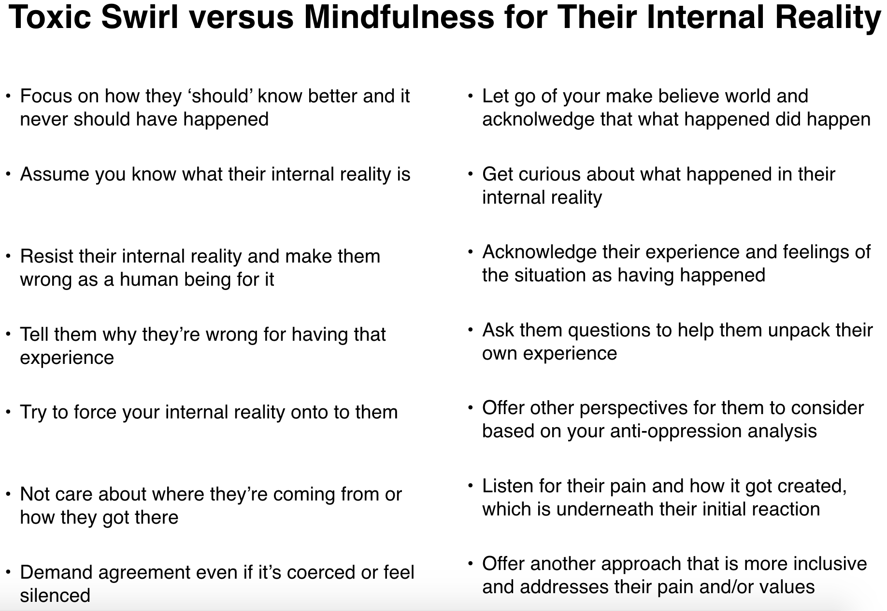
However if we approach BEFORE we’ve taken care of ourselves, then we will approach them with toxic swirl - and that almost never goes well.

Why It’s So Hard (But It Doesn’t Necessarily Have To Be)

Why It’s So Hard To Have the Conversation (But It Doesn’t Necessarily Have To Be)

  - Unless there’s a threat of imminent physical threat or an act of physical violence, it’s just some words, some actions, and some energies happening in external reality.
  - In our internal reality, those external words, actions, and energies cause harm because they set off our internal pain that we’ve been carrying.
  - The external situation is emotionally charged because we resist the pain it’s setting off and therefore, resist the external reality and the other person’s internal reality.

So these external words, actions, and energies DO NOT have to cause us harm if we take care of our pain and acknolwedge external reality and the other person’s internal reality as they are.

What This Conversation Is About
- It’s not about making them wrong. It’s about sharing your truth.
- It’s not about them changing their minds. It’s about you wanting to understand their truth.
- It’s not about getting them to stop. It’s about you taking care of yourself and treating yourself like you matter.

How To Have the Conversation When It’s Emotionally Charged
- Apply the first three practices of Compassionate Activism to yourself first!
  - Practice of Humility and Curiosity
  - Practice of Distinguishing Realities and Acknolweding External Reality
  - Practice of Gentle Mindfulness and Compassionate Self-Accountability

- Apply the first three practices to the other person! It’s that simple.

Share Your Truth
  - Share your internal reality as part of your own compassionate self-accountability and in service of your own healing
  - It’s about you and what you need to give yourself. It’s not about how they receive it or if they agree with it.
  - At most, you can invite them to consider it as your experience while acknowledging that they also may have a different experience of the situation. They have the right to say no and they just may say yes.

Just Ask!
- Inquire to meet them in their internal reality
- Invite them to meet you in your internal reality
- Use your own perspective and anti-oppression analysis to help them unpack their initial reaction and get in touch with the pain in their internal reality that’s driving their initial reaction.

Stay Focused on the 3 Realities

- More effective if the person who's more stuck in the toxic swirl shares their internal reality first.
- If both people are struck in the toxic swirl, make sure to take care of yourself first and foremost.
- It’s not about who’s most calm because you can be calm and be in toxic swirl.
- It’s about who’s more focused on the 3 realities, which can be communicated in a fierce and loud and express anger, frustration, and resentment.

Practice #5:
Shared Envisioning and Non-Cooperation

Co-Creating a Shared Vision

- Through the Fourth Practice of Compassionate Truth-Telling and Consciousness-Raising Inquiry,
    - Get connected.
    - Identify shared values/goals/interests that are core to each other’s realities.

- Given your new understanding of each other’s realities, create a solution that honors the shared core values.
  - Do not get fixated on the position you’ve taken previously (yes, X but, Y). Focus on the shared interest.
  - Try “Yes [insert their perspective], and [your perspective]. So how about we try X together?”

- If fear from the past presents itself through feeling stuck, go through Practice 1-3 again.

Compassionate Non-Cooperation

- You can’t control their behavior but you can choose yours.
- If you can’t co-create an agreement, then choose to disengage - while hoping for their best, including being able to co-create in the future.
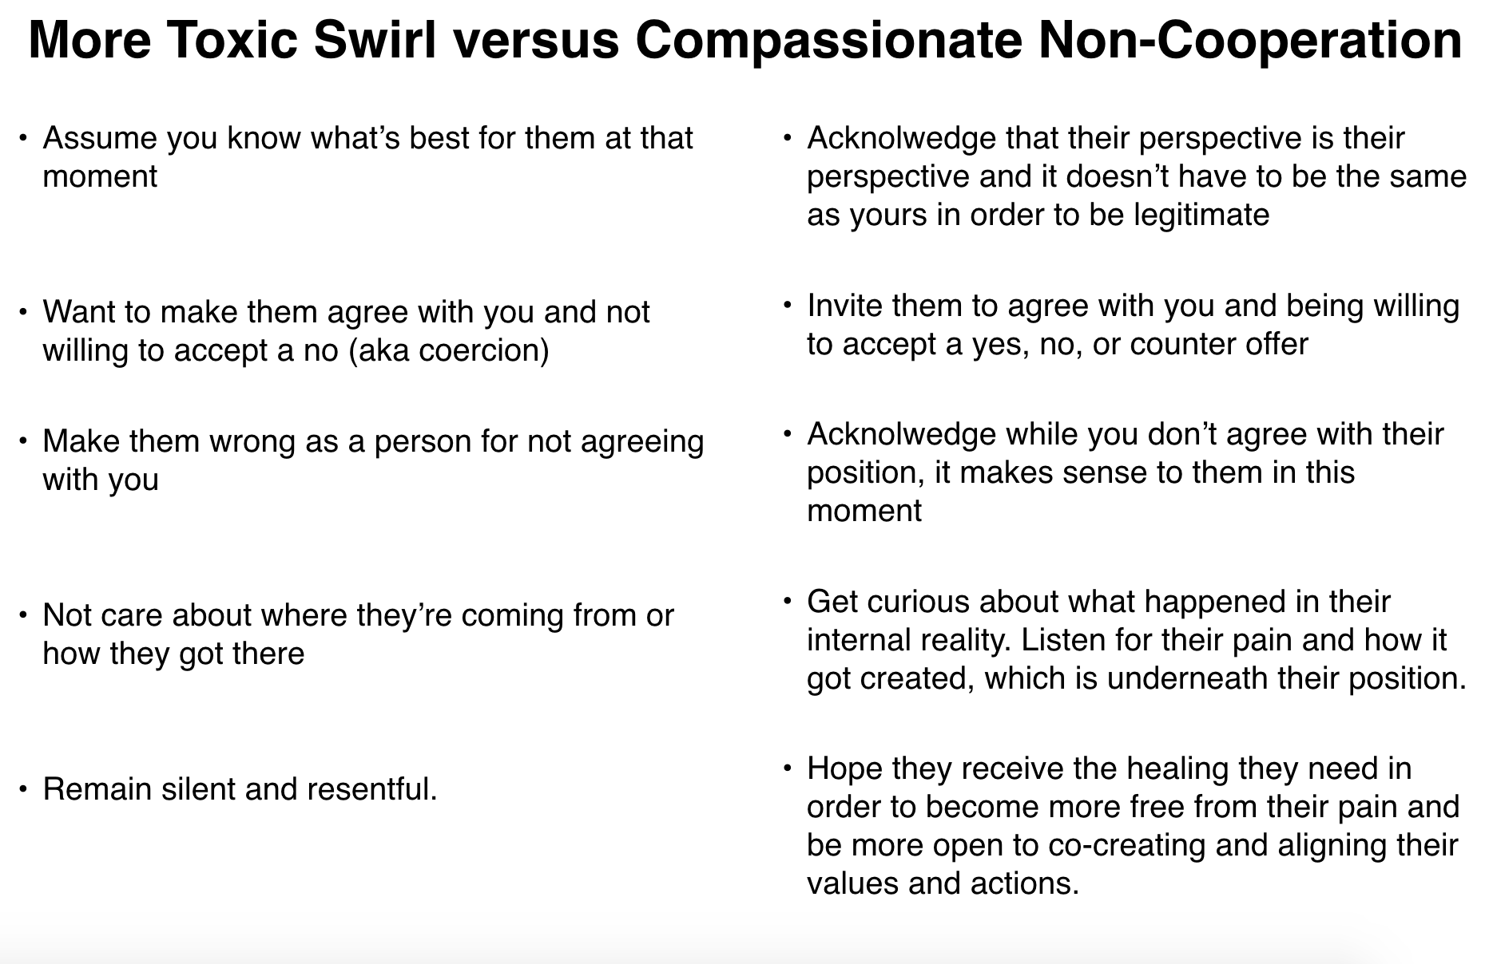
- It’s also important to grieve for the unfulfilled hope and lost opportunity to create something meaningful together.

